PROJECT ARCHITECTURE
USER FLOW

Field | Details
Date | 26 June 2026
Team Id
Project Name | House Rent
Maximum Marks | 4 Marks

User Flow
The HOUSE RENT application follows a simple and user-friendly workflow that allows tenants to search for rental properties, communicate with property owners, and complete the rental process efficiently.

User Journey
1. Start
The user begins their journey to find a rental property.
2. User Opens HOUSE RENT Application
The user launches the HOUSE RENT application using a web browser or mobile device.
3. User Registers or Logs In
- New users create an account by providing the required details.
- Existing users log in using their registered email and password.
4. User Searches for a Property
The user searches available rental properties using filters such as:
- Location
- Rent Range
- Property Type
- Number of Bedrooms
- Amenities
5. Property Suitable?
- Yes: The user proceeds to view the complete property details and contacts the owner.
- No: The user continues searching for another suitable property.
6. User Contacts the Owner
The user can send an enquiry or communicate directly with the property owner regarding the selected property.
7. End
Once both parties finalize the rental agreement, the in-application journey ends. Any further discussions, agreements, and payments are completed offline.

Advantages of the User Flow
- Simple and intuitive navigation.
- Quick property discovery using search filters.
- Easy communication between tenants and owners.
- Smooth rental process with minimal steps.
- Improved user experience and accessibility.

Example- UserFlow Diagram:
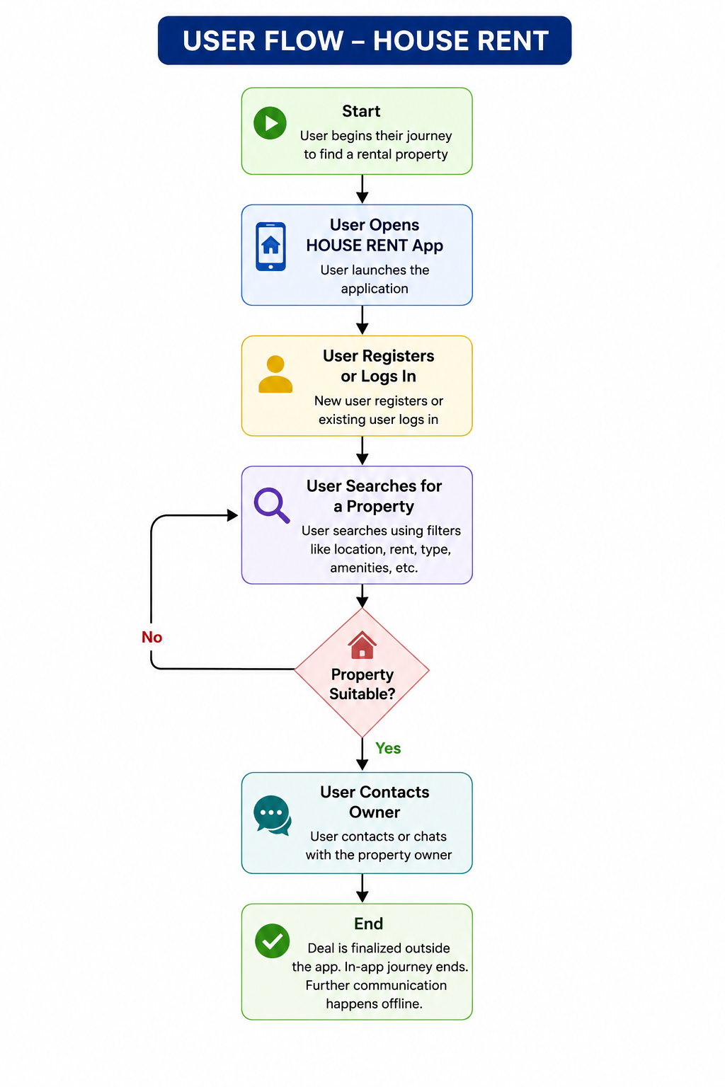Figure 1: User Flow of the HOUSE RENT Application

Reference:
- https://www.lucidchart.com/pages/user-flow
- https://www.figma.com/resource-library/user-flow/

